**TASK -3:-MOTION DETECTION SECURITY SYSTEM**

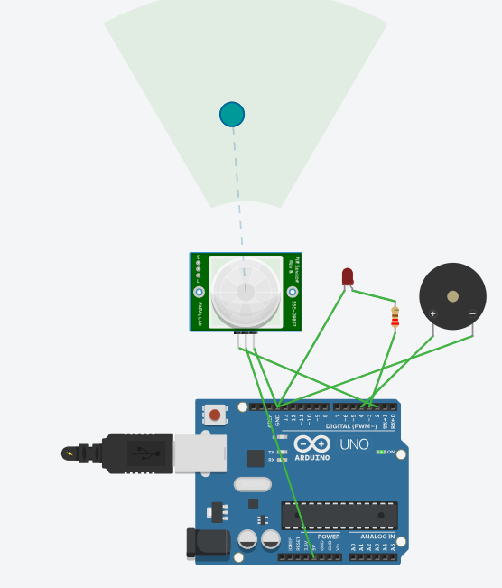

**Code:-**

int pirPin = 2; // PIR sensor output pin

int ledPin = 3; // LED pin

int buzzerPin = 4; // Buzzer pin

int pirState = LOW;

void setup() {

pinMode(pirPin, INPUT);

pinMode(ledPin, OUTPUT);

pinMode(buzzerPin, OUTPUT);

Serial.begin(9600);

}

void loop() {

int val = digitalRead(pirPin);

if (val == HIGH) {

digitalWrite(ledPin, HIGH);

digitalWrite(buzzerPin, HIGH);

if (pirState == LOW) {

Serial.println("⚠️ Motion Detected! Sending alert...");

pirState = HIGH;

}

} else {

digitalWrite(ledPin, LOW);

digitalWrite(buzzerPin, LOW);

if (pirState == HIGH) {

Serial.println("✅ Motion ended.");

pirState = LOW;

}

}

**}**